**Component 1 :- Checklist**

Student Name/ID: Niroj Kumar Dhimal /77275270

Development Choice: vs code / XAMPP

**Screenshots are mentioned below as a successful setup showing project window with case study.**

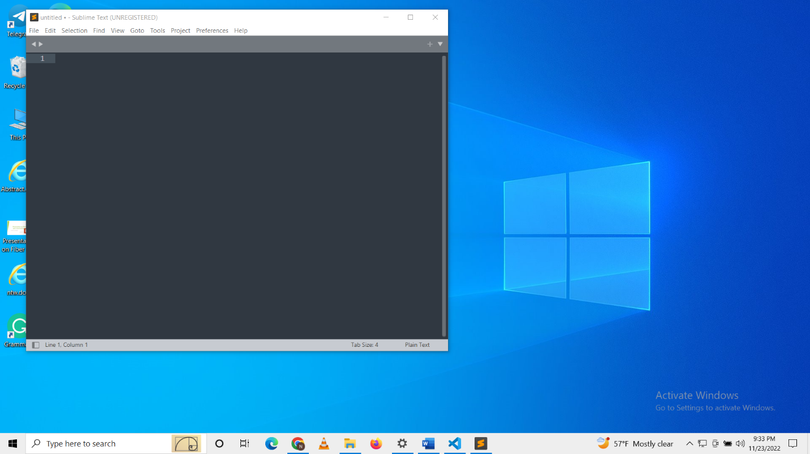

**Fig: Sublime text 4**

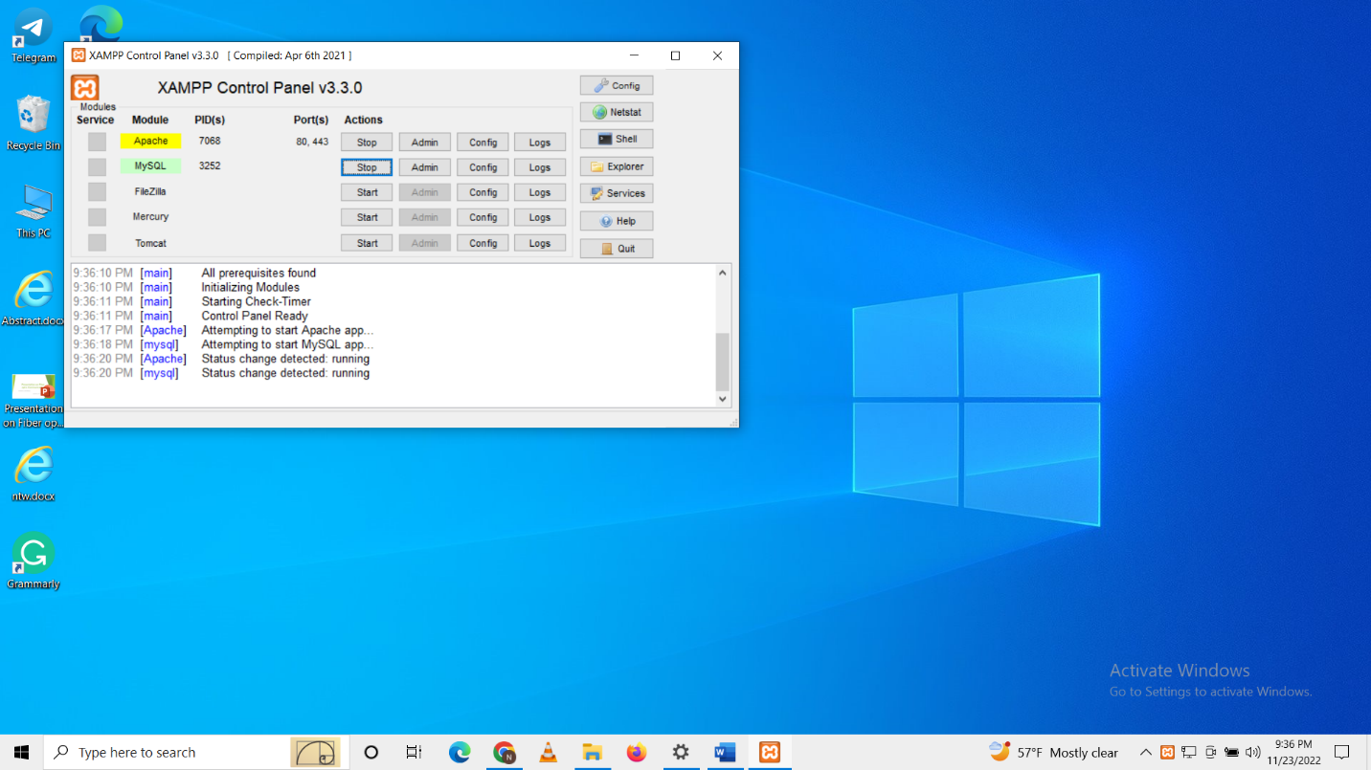

**Fig: Xampp control panel**

**PHP Version being used: ‘PHP 8.1.10 (cli) (built: Aug 30 2022 18:05:49) (ZTS Visual C++ 2019 x64))’**

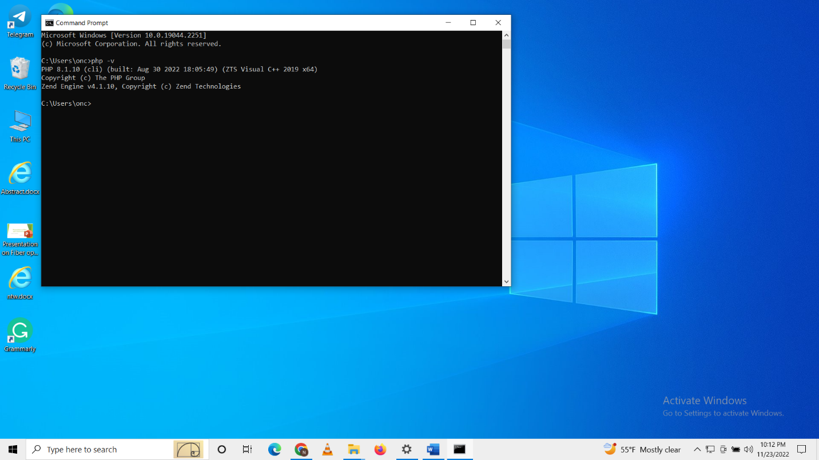

**Fig: Command showing php version**

**XDebug installed: Yes**

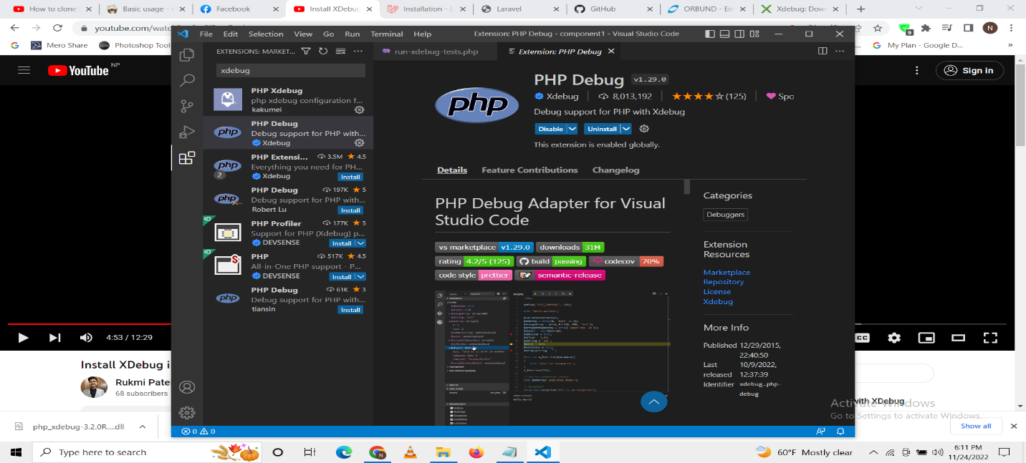

**Fig: Xdebug installed on vscode**

**Git account creation**

**link:** <https://github.com/dniroj21/comp1.git>

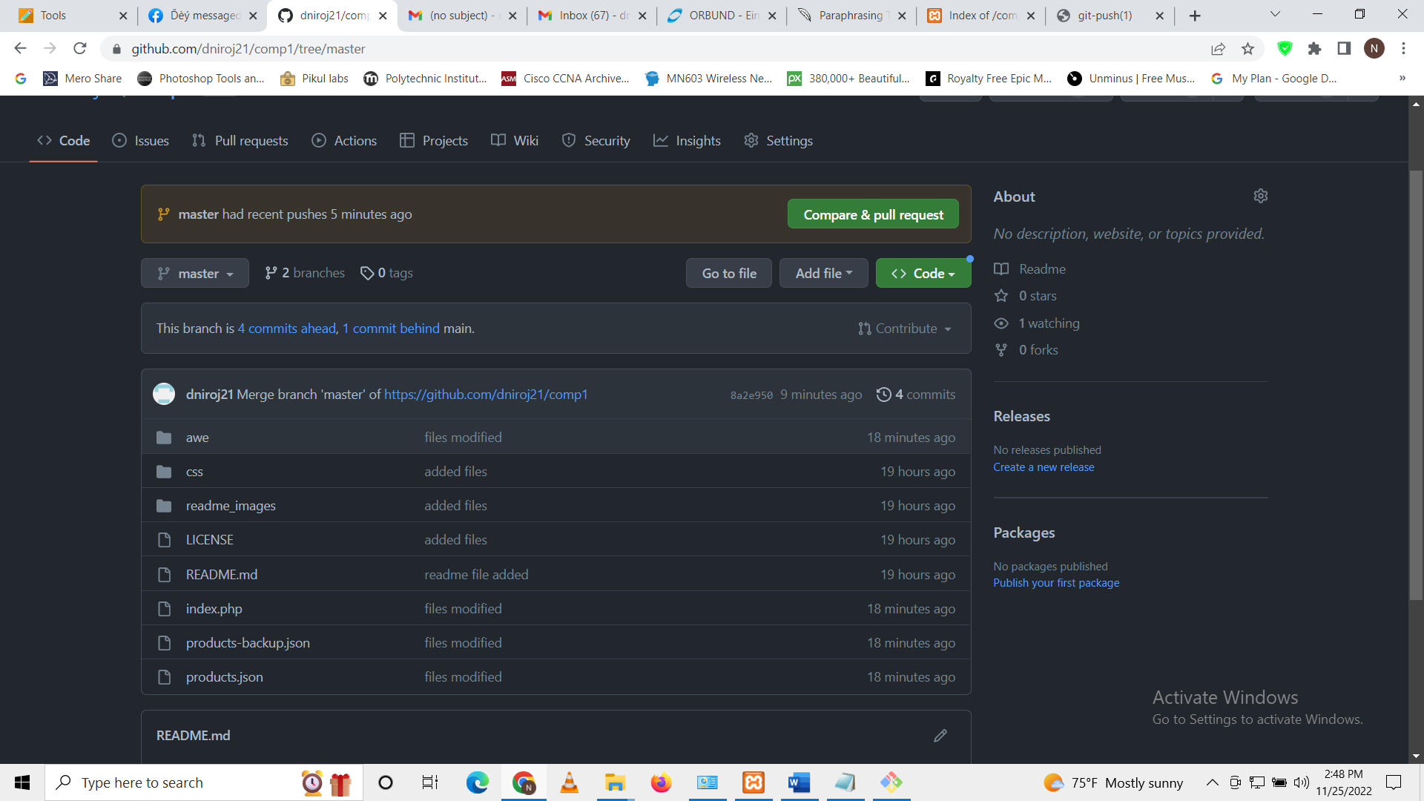

**PHP Exercises done?**

(add 3-5 screenshots of changes/updates you made in the repo - frontend as well as code)

